For the problems in the first part, no submission is required.

1] Read Example 1 on p.77 of our text:

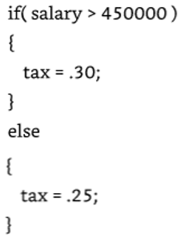

(a) Write a complete program that contains this **if** statement. (Do not forget to declare the variables *salary* and *tax*! The value of the *salary* is entered from the keyboard.)

* Verify the behavior for salaries below and above the threshold.
* What gets printed if the salary is equal to 450000?

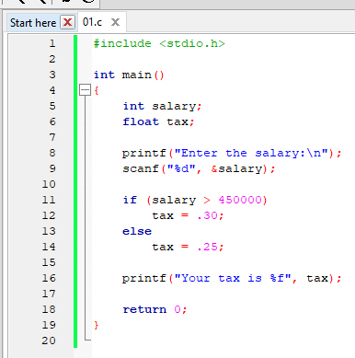

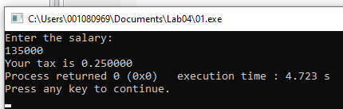

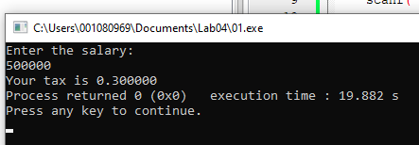

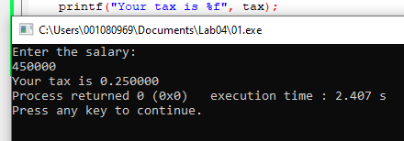

(b) Modify the program to make the same decision, but using a **conditional operator** instead of an **if** statement.

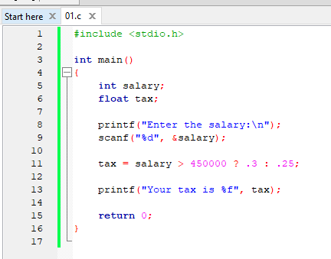

Review of if statements:

2] Write a program with **if** statements that ask the user for an integer value x, and then display different messages as follows:

* ‘x strictly less than 50’
* ‘x between 50 and 100’
* ‘x strictly larger than 100’

🡪Test with these values: x = 20, 60, and 110.

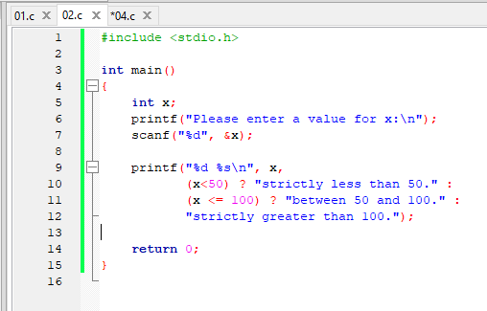

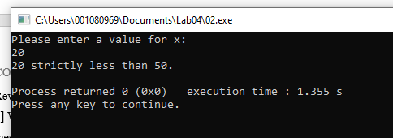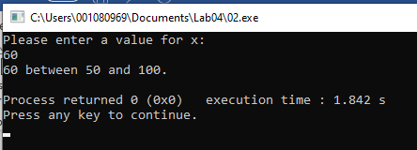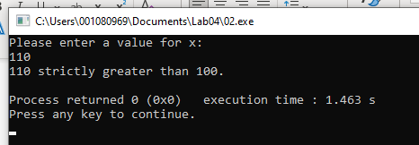

**Functions**

3] Solve Exercises 1 and 2 at the end of Lesson 5 (p.116). 🡪Pencil and paper only.

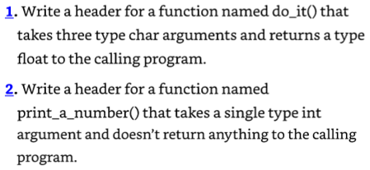

🡪Answers:

1. float do_it(char a, char b, char c); though headers don’t require variable names.

2. void print_a_number(int a);

4] Solve Exercise 10 at the end of Lesson 5 (p.118):

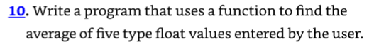

🡪Test the program with the values: 1.5, 2.5, 3.5, 4.5, 5.5

Example:

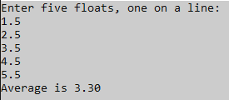

The average in the example is wrong!?

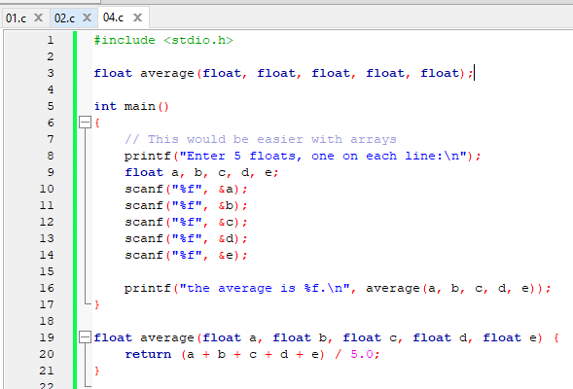

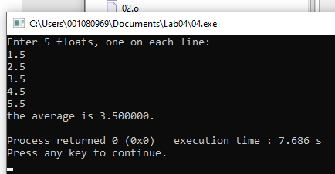

5] Write the program shown in the lecture, with a recursive function that calculates the sum of integers from 1 to n:

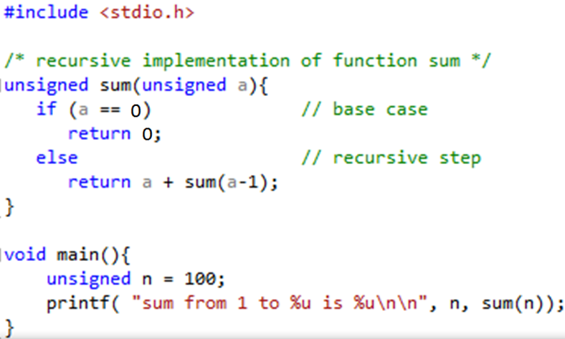

Test with n = 10, 100, and 1000.

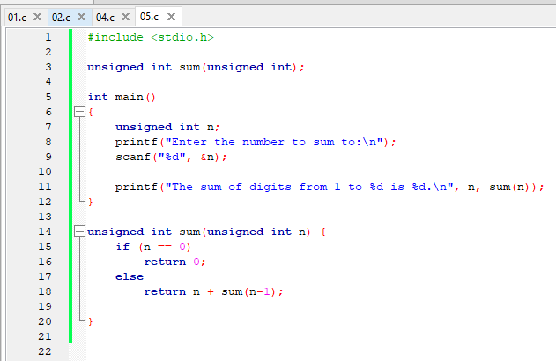

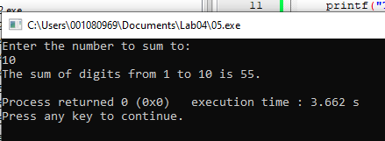

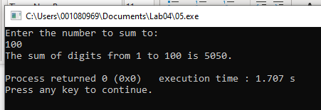

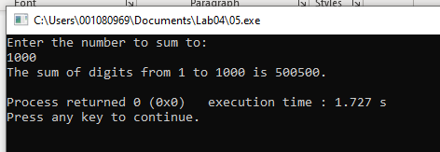

**To submit for lab report**

--- All problems in this section require screenshots of source code and output! ---

1] Write a program with a function that calculates the volume of a sphere. The function takes one argument – the radius.

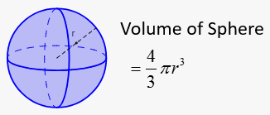

The user should enter the value of the radius as a double from the keyboard. Pi should be a symbolic constant using the keyword *const*. Hints:

* The placeholder for double is %lf (long float).
* Test the program with r = 2.1.

🡪 Include a screenshot of your source code and output.

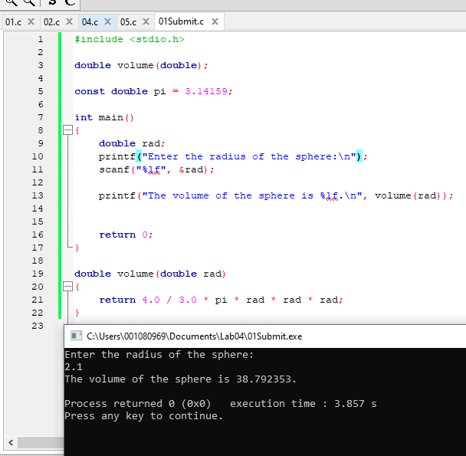

2] Code this recursive function in a C program:

**int mystery(int i, int j) {**

**if (i == 0)**

**return j;**

**else**

**return mystery(i-1, j+1);**

**}**

Call the function in the main program with these pairs of arguments:

• i = 2, j = 1 🡪 3

• i = 2, j = 2 🡪 4

• i = 3, j = 4 🡪 7

🡪 Take a screenshot of each output and include it in the lab report.

Based on the results above, what would be a good name for this function? A: add  
it adds I to J.

